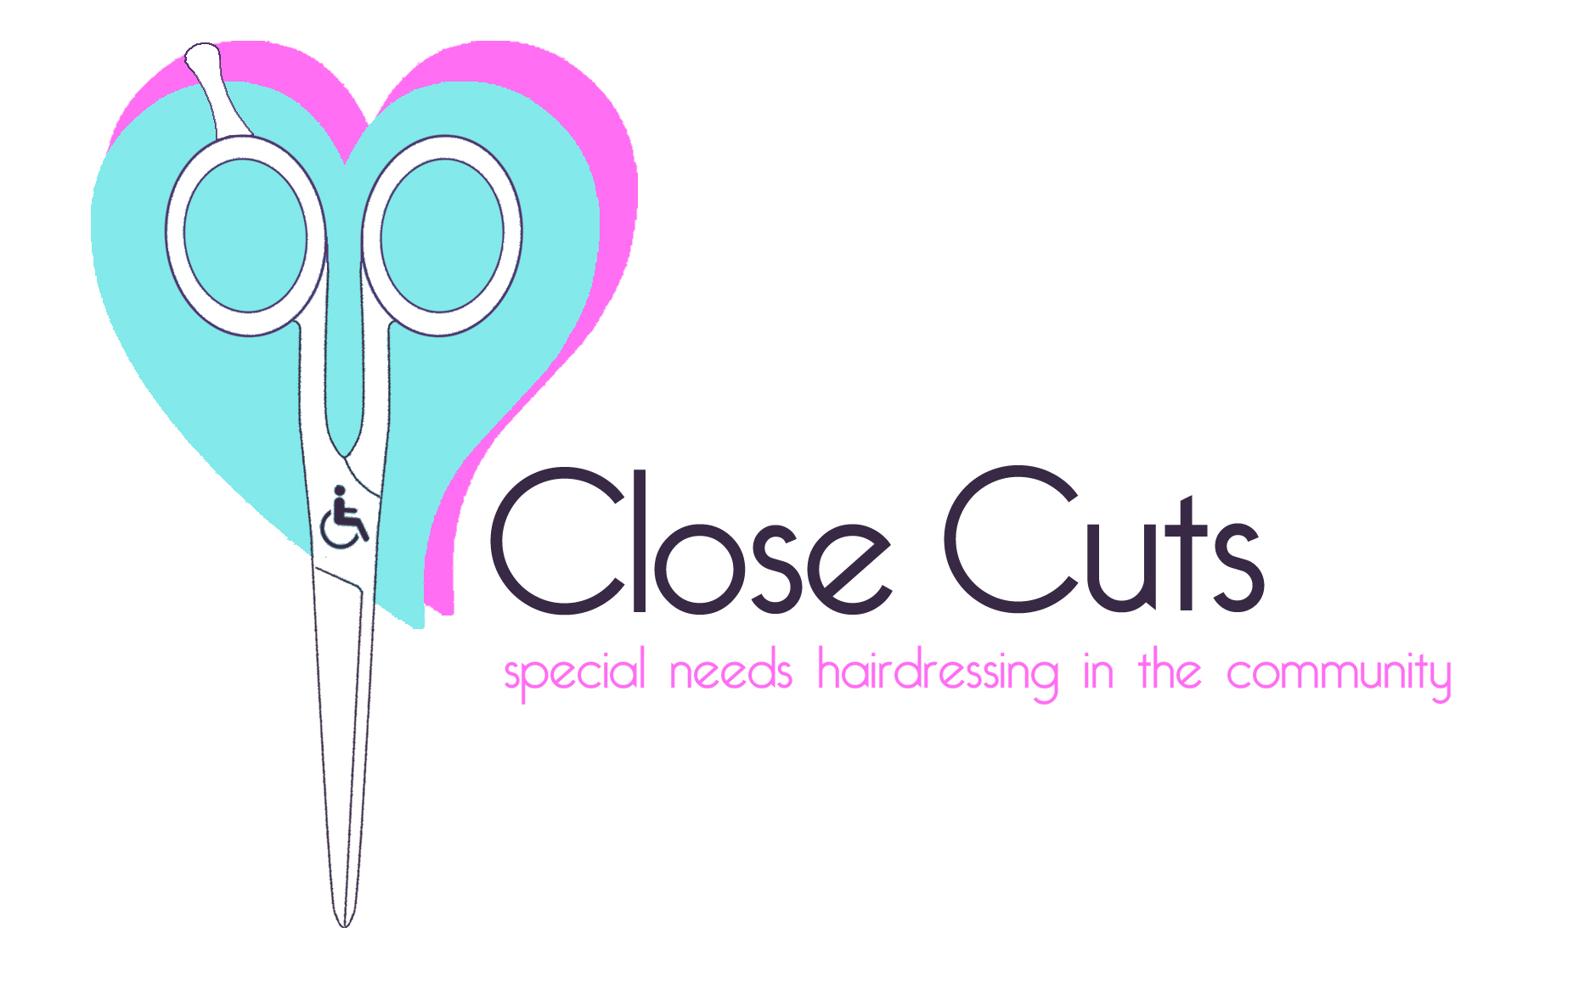
At
Warren Park Respite Centre Kingston surrey KT2 7LX

I’m Gina and I have 27 years experience plus I have a special needs child so I know how hard it is to take them to a salon and expect them to behave.
Kids are relaxed and respond well to the safe and playful environment so give it a try we don’t bite!
10-1 pm
(From only) £ 5.00 per cut
Future dates:
16th January, 13th Feb, 13th March, 10th April, 8th May,12th June,10th July 2011.

Full CRB and Insured call me on 07970-833652 or email on ginaginaselby@hotmail.com
Or Gina@closecuts.co.uk

